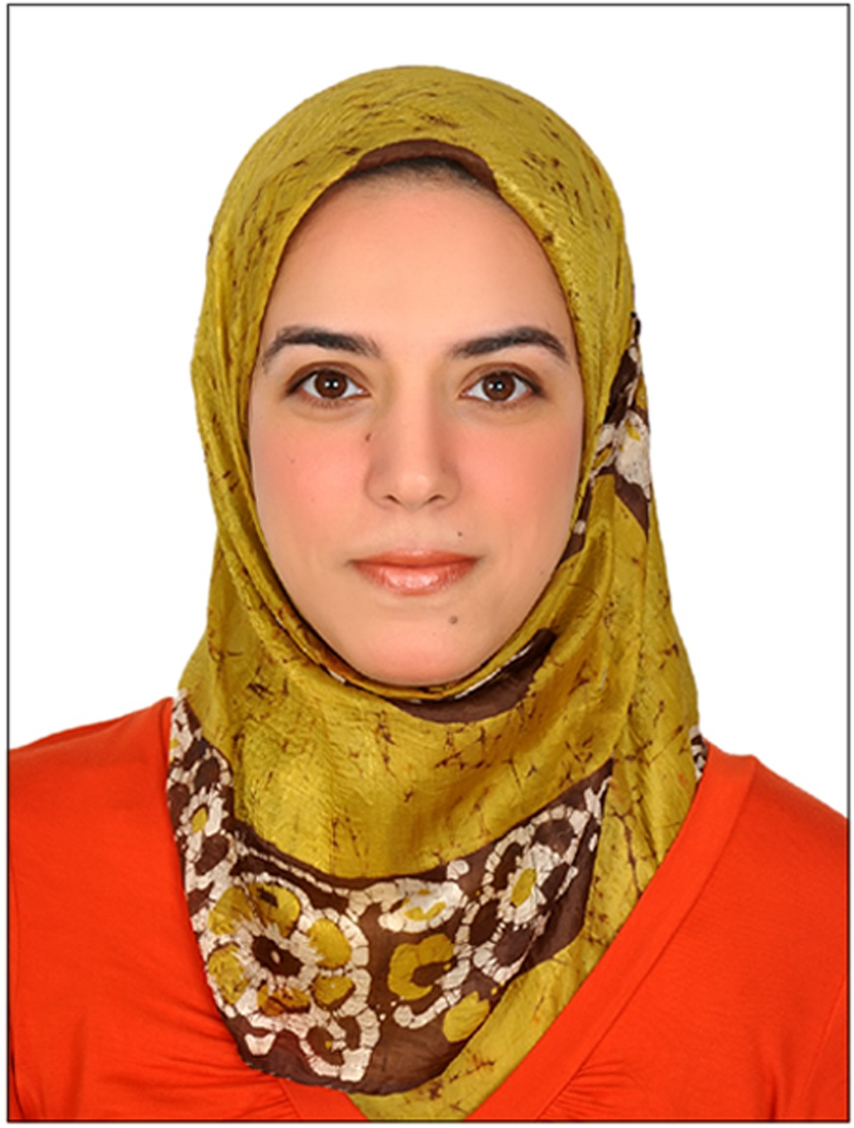
Viviane Morad Sami Gharib Mohamed

E-mail: viviane_morad28@yahoo.com

Academic Background:
- Currently, in the process of completing the Ph.D. in Statistics, Dept. of Statistics, Faculty of Economics & Political Science, Cairo University.
- 2009, M.Sc. in Statistics, Faculty of Economics & Political Science, Cairo University. Grade: Excellent.
- 1999, B. Sc. in Statistics, Faculty of Economics & Political Science, Cairo University. Major: Statistics. Minor: Computational Socio-Sciences. Grade: Excellent with Honors.
- 1989, 1992, 1995, Certificates of Primary, Preparatory and Secondary Education, Lycee El Horreya.

Academic Experience:
Assistant lecturer – Dept. of Statistics – Faculty of Economics & Political Science – Cairo University (2009-present).
Teaching Assistant – Dept. of Statistics – Faculty of Economics & Political Science – Cairo University (1999-2009).

Research Interests:
Applied Statistics, Data Modeling & Analysis, Applied Econometrics, Developmental & Population Studies.

Conferences:
A paper entitled "Modeling and Analyzing a Bank Queueing System – a Case Study", in the Annual Conference on Statistics and Modeling in Human and Social Sciences, Dept. of Statistics, Cairo University.

Some of the Workshops & Courses attended:
- “The Use of the Survey of Young People in Egypt (SYPE) data” (By the Population Council – West Asia & North Africa - Egypt).

- “Measurements of Inequality of Opportunity and Inequality of Outcomes” (By the Economic Research Forum (ERF) - Egypt).

- "Methodology of the Survey of Young People in Egypt (SYPE)" (By the Population Council – West Asia & North Africa - Egypt).

- "Capacity Building on: Measures & Indexes of Poverty and the Different Methods of Targeting the Poor" (By the Social Contract Center – Egypt).

- "Research Methods for Political Science" (By The American University in Cairo (AUC) – Egypt).

- "Data Quality Assessment & Data Imputation using SAS, BANFF, and STATA" (By Statistics Dept. – Faculty of Economics & Political Science – Cairo University).

Language Skills: Arabic (Mother tongue), French & English (Excellent read & written, V.Good spoken).

Computer Skills: STATA, SPSS, Minitab, DataDesk, Arena, and some SAS.

